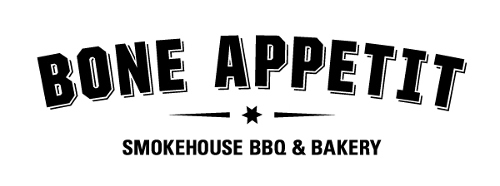
Sale proceeds will go to the
Lyons Wrestling Club
The Community Health Fair 2011
is selling pre-sale tickets to purchase fresh prepared Chicken BBQ Dinners
to be picked up at the Health Fair
from 11:30 am to 1:00 pm on
Saturday, April 2, 2011 at the
Lyons Community Center
located on Manhattan Street in Lyons, NY

Dinners will include: ½ Chicken (dry rubbed & smoked)
Salt Potatoes
Cole Slaw
Cost of each dinner is $10.00
Cash or check accepted (checks made payable to Lyons Wrestling)

Prepared by the local
180 Geneva Street
Lyons, New York 14489
315-946-4600
Questions should be directed to Jill Harper at
315-946-2200 ext. 2504

Name ________________________________________________ Phone Number __________________________

Number of Chicken BBQ Dinners ______________________ Amount Paid ___________________________
O Cash O Check #________

The Community Health Fair 2011

All pre-sale orders must be paid in full by March 24, 2011 and returned to Mrs. Jill Harper
Lyons MS/HS
10 Clyde Street
Lyons, N.Y. 14489

